**Scenario 1: Working with Courses**

**Queries**

which will get added both courses names, created date and Price

Syntax

Select title, date_created, price from courses

Where title='Advanced3'

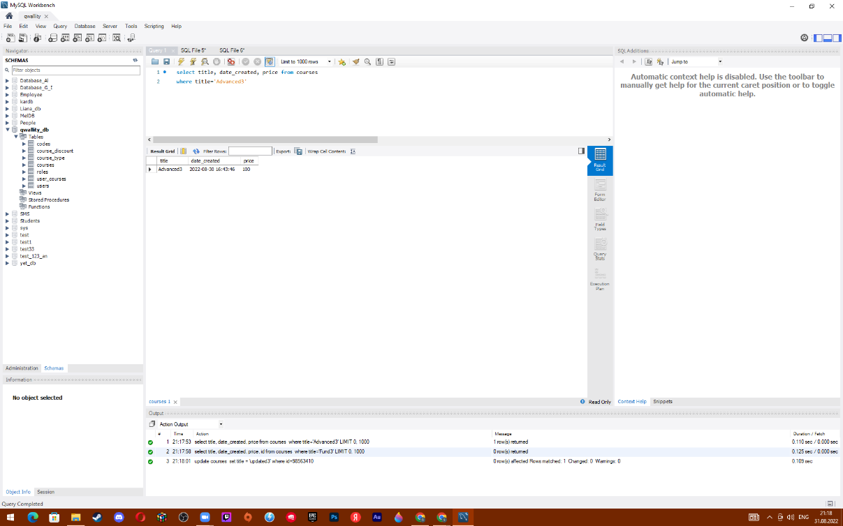

which will update created Fundamental course name to “**Updated title**”

Syntax

Select title, date_created, price, id from courses

Where title='Fund3'

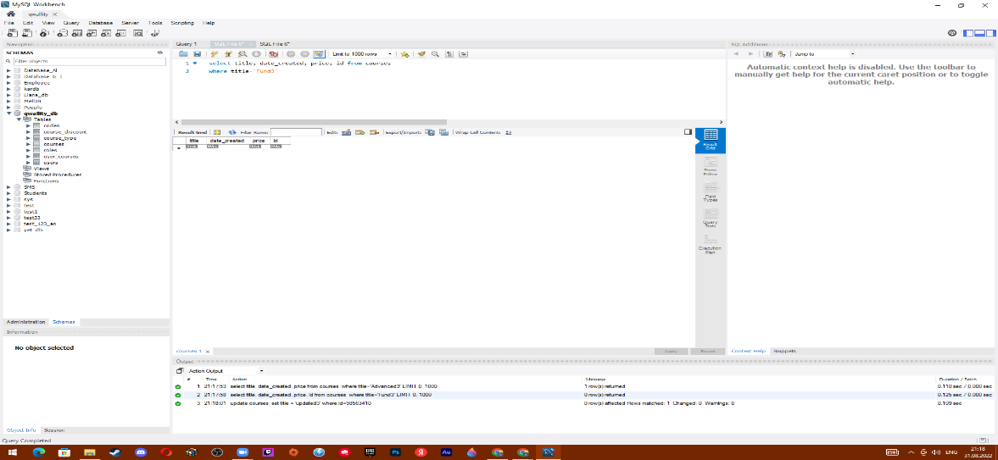

which will update created Fundamental course name to “**Updated title**”

Syntax

update courses

set title = 'updated3'

where id=98563410

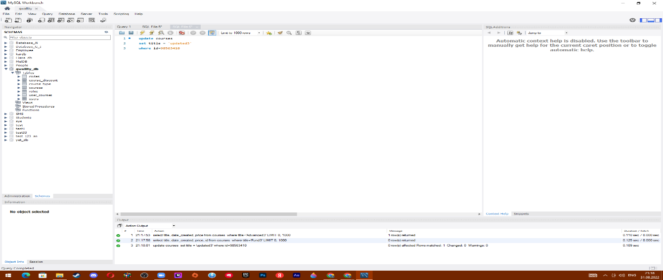

**Which will remove Advance course**

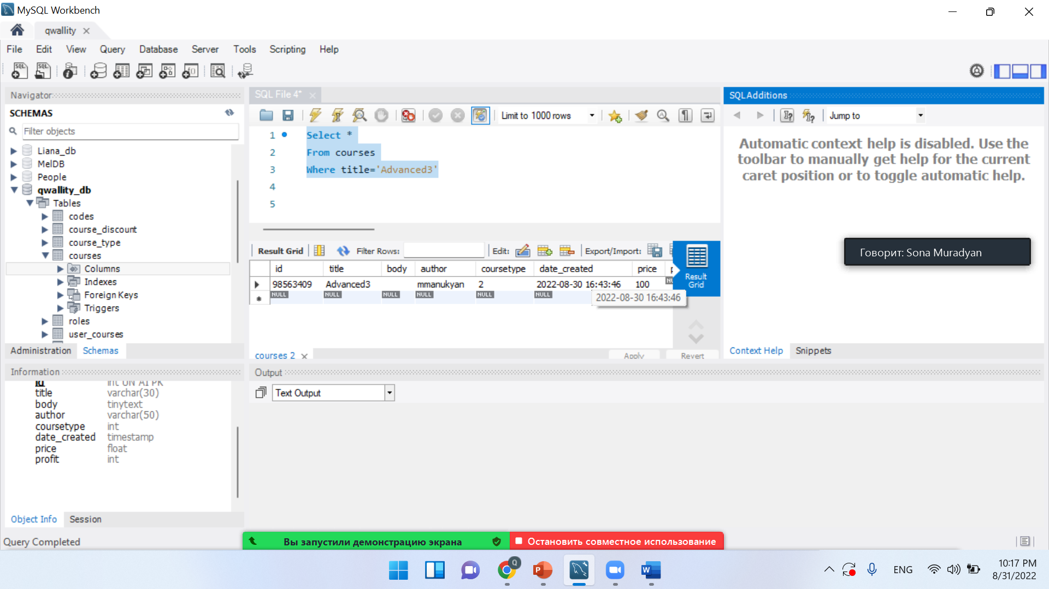

**Syntax**

**Delete from courses**

**Where id=98563409**

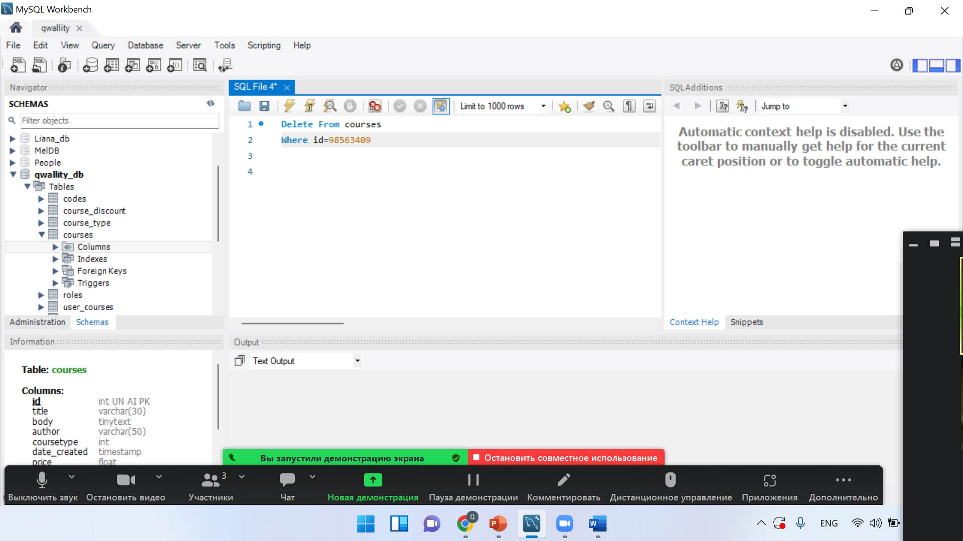

**Cheching in db**

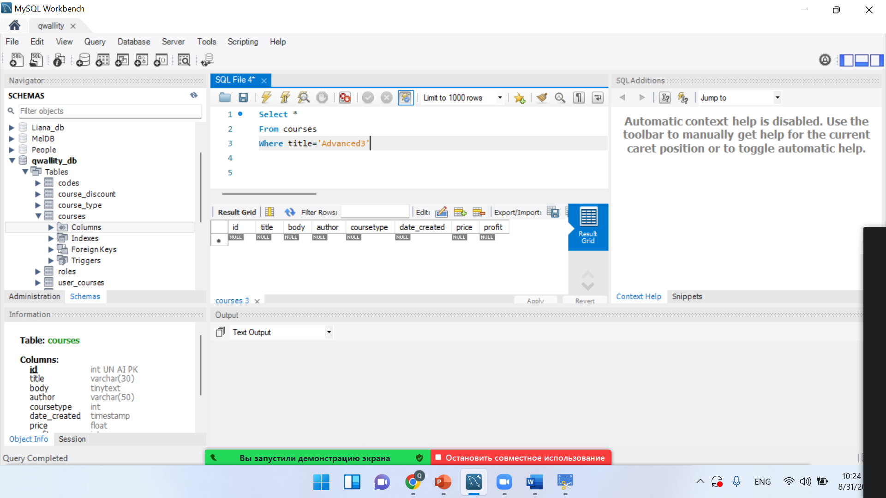

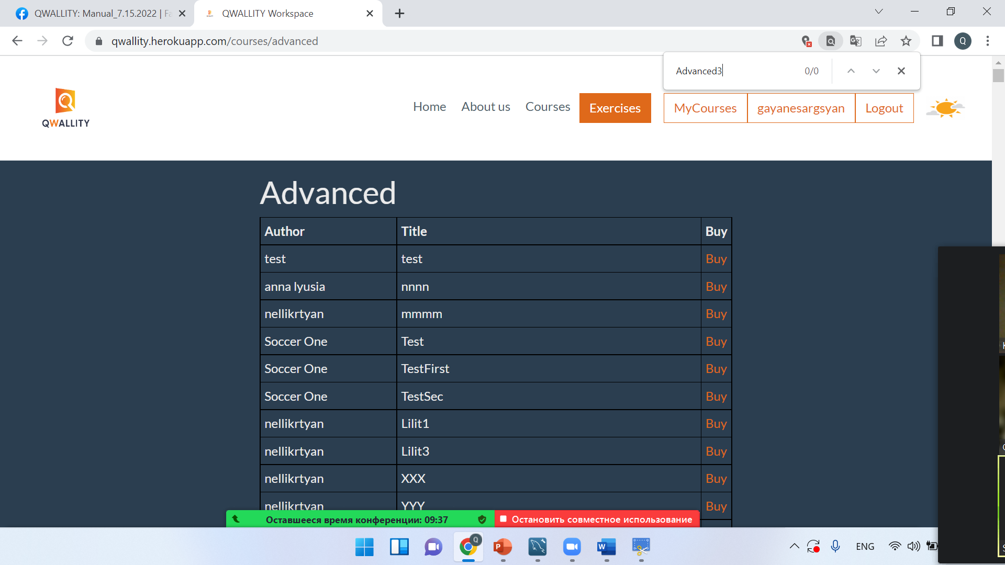

**Scenario 2: Buy Courses**

**As a non admin, login to the system-done**

**Buy 2 Fundamental and 3 Advanced courses**

|  |  |  |
| --- | --- | --- |
| **Author** | **Title** | **Buy** |
| nellikrtyan | lilit6 | [Buy](https://qwallity.herokuapp.com/courses/course/15884) |
| nellikrtyan | ZZZ | [Buy](https://qwallity.herokuapp.com/courses/course/15887) |

**Buy 3 Advance**

|  |  |  |
| --- | --- | --- |
| **Author** | **Title** | **Buy** |
| test | test | [Buy](https://qwallity.herokuapp.com/courses/course/15856) |
| anna lyusia | nnnn | [Buy](https://qwallity.herokuapp.com/courses/course/15860) |
| nellikrtyan | mmmm | [Buy](https://qwallity.herokuapp.com/courses/course/15865) |

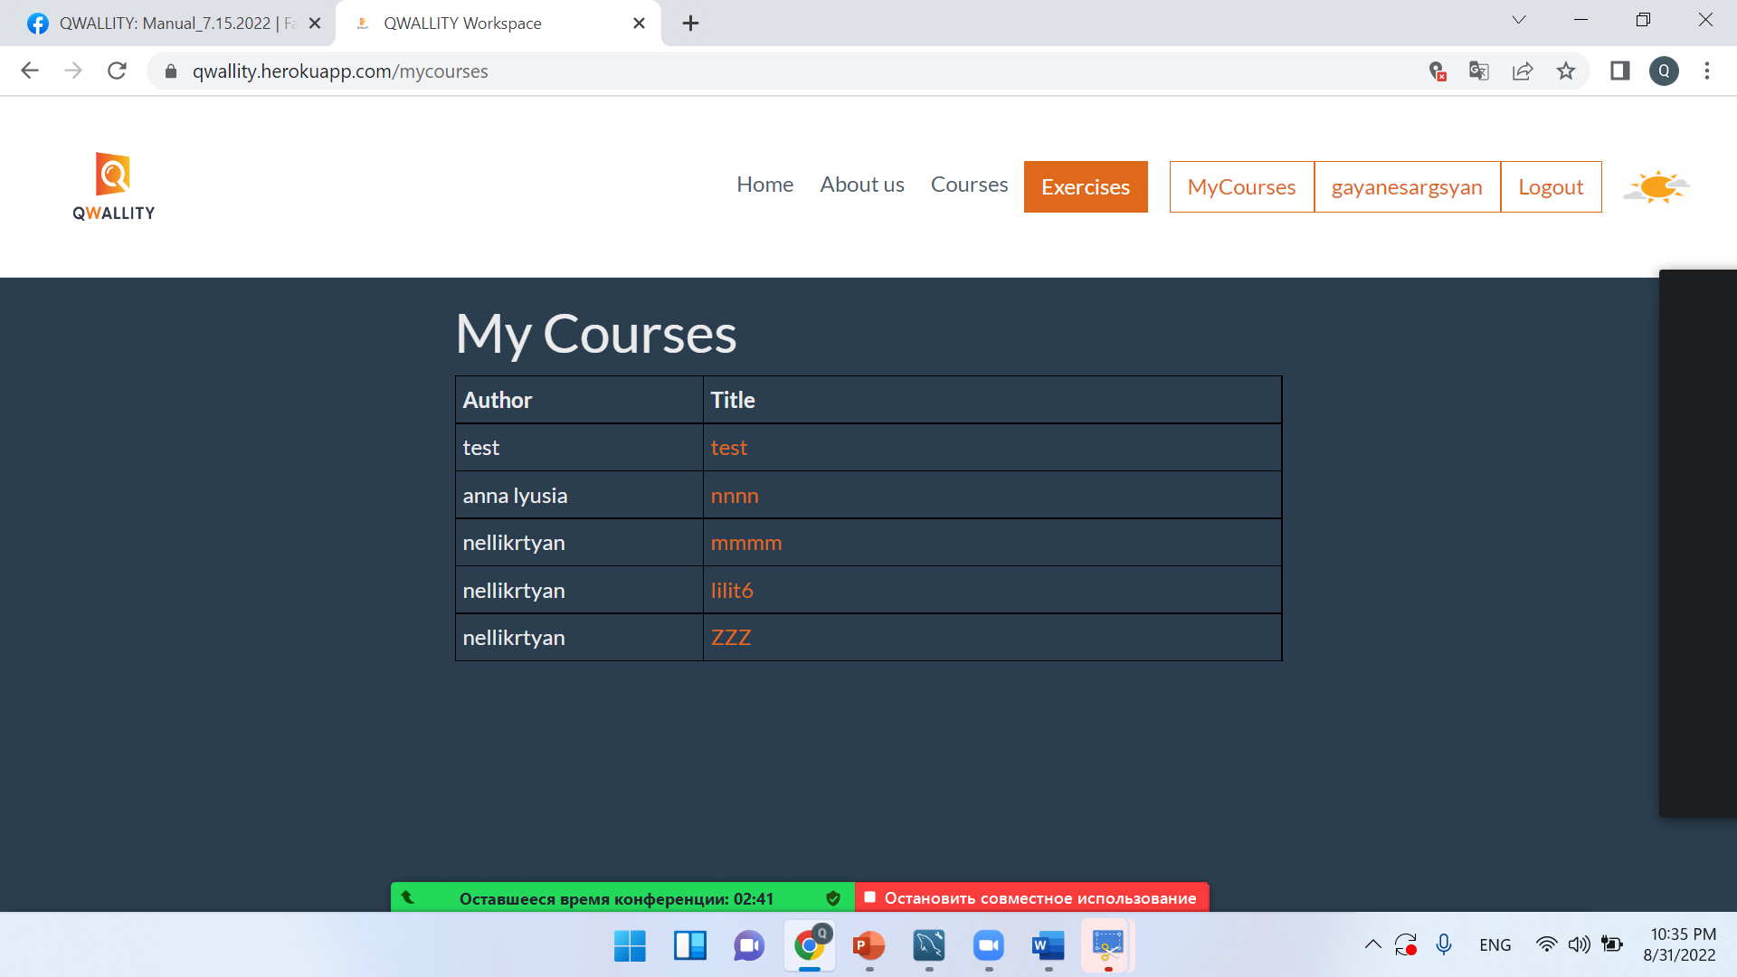

**Queries**

***Which will select non admin user all courses***

**Syntax**

**Select users.username, users.role_id,user_courses.course_id**

**From users**

**Inner Join user_courses**

**On users.id=user_courses.id**

**Where users.role_id=2**

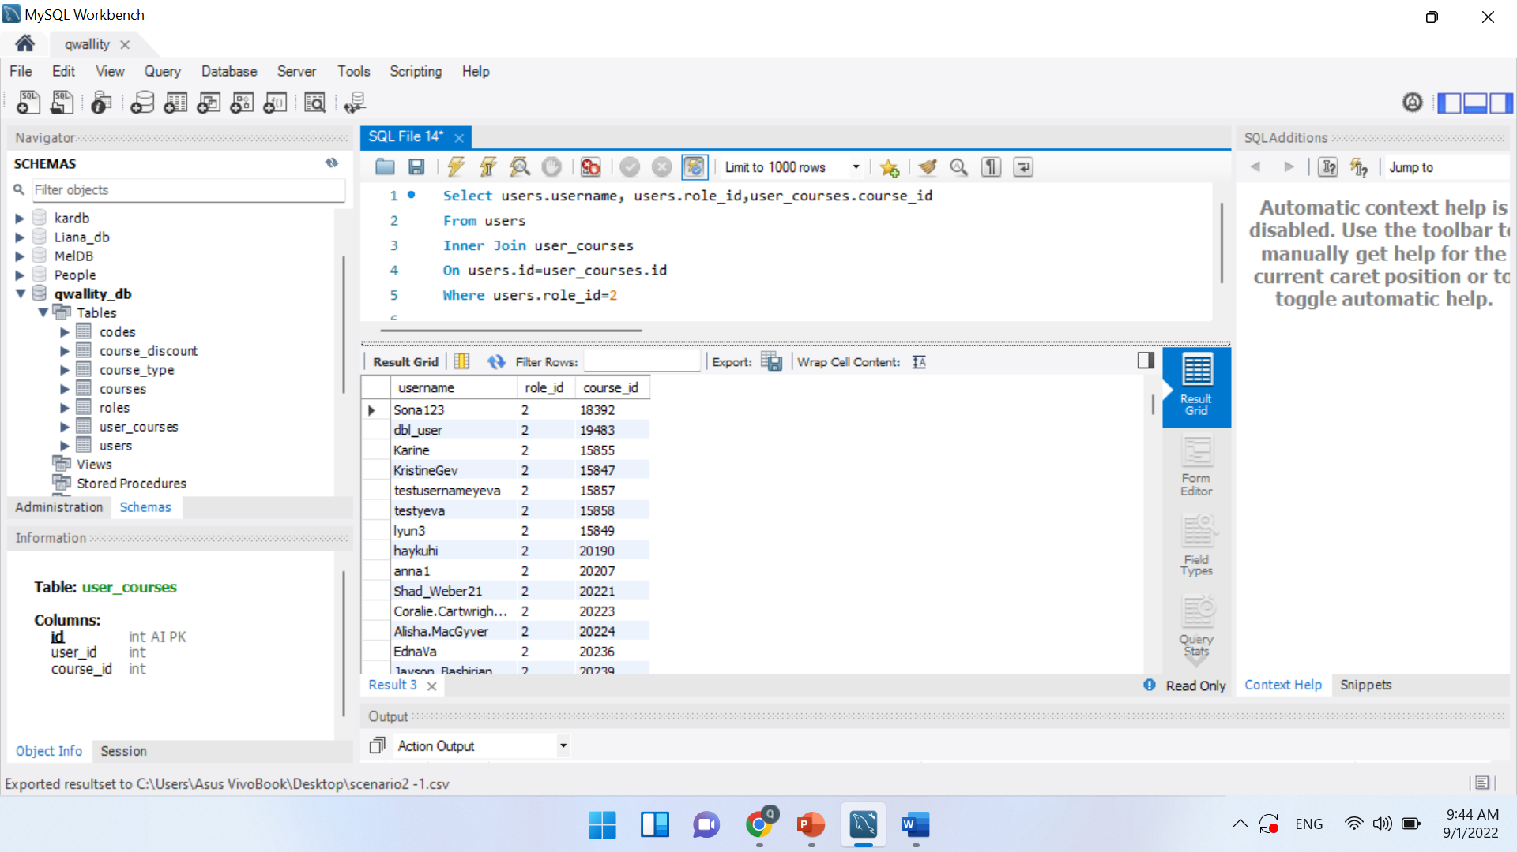

***Which will select count of Fundamental and Advanced course***

***Syntax***

Select count(coursetype)

From courses

Where coursetype IN (1,2)

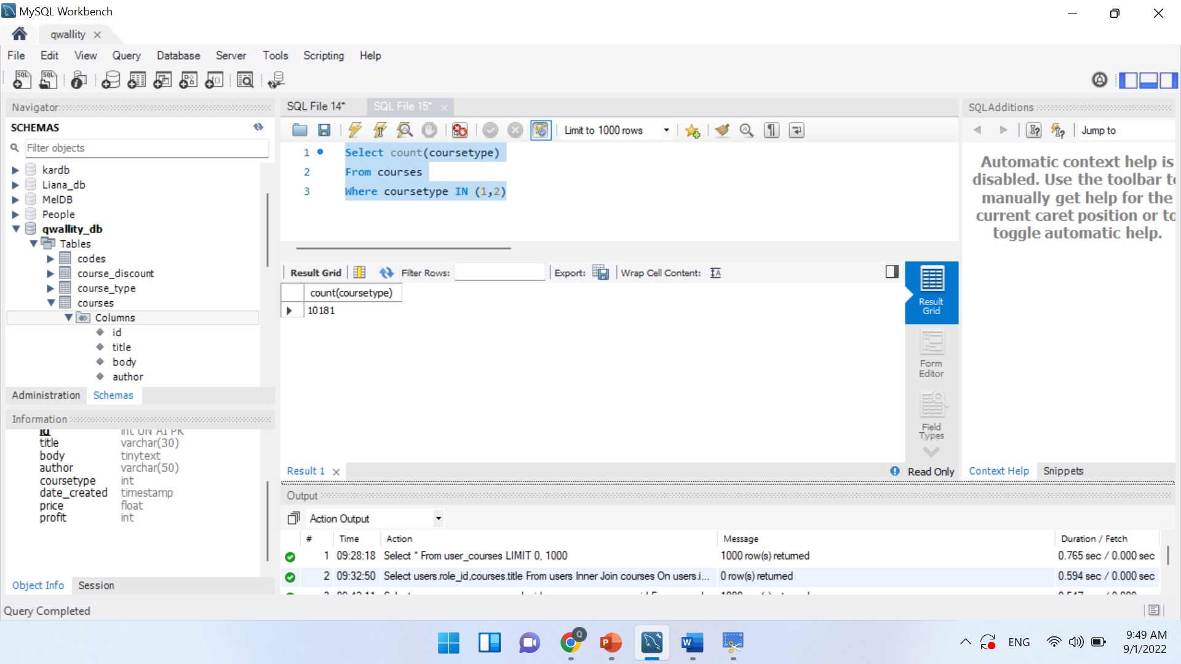

***Which will insert new Fundamental course to non admin account***

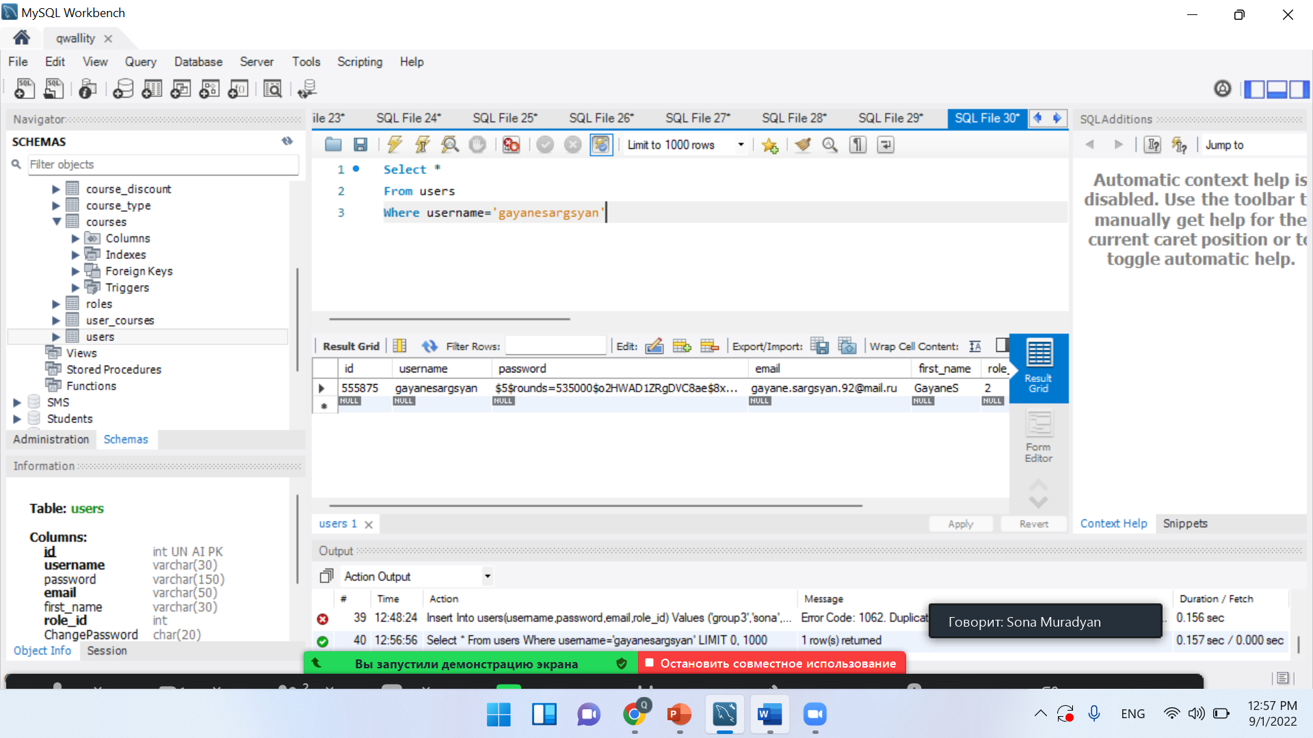

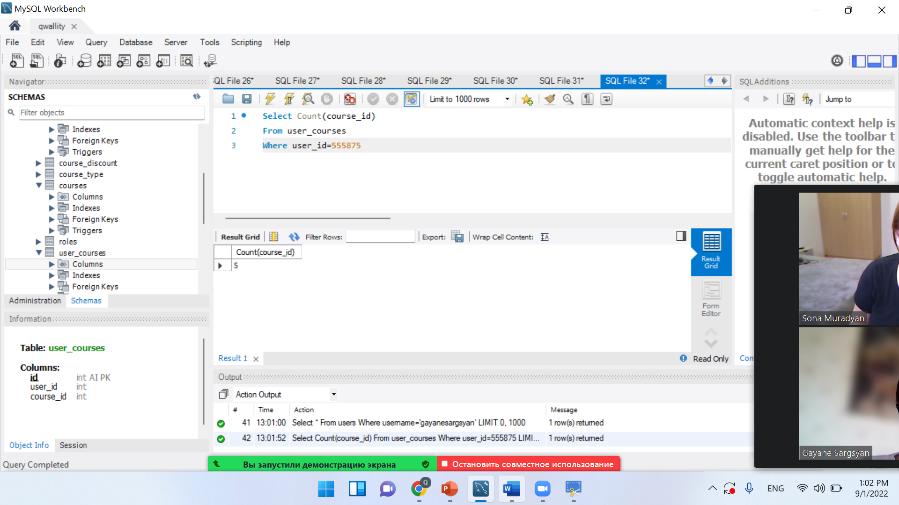

Insert into user_courses (user_id, course_id) Values (1234597, (select id from courses where coursetype=1 LIMIT 1))

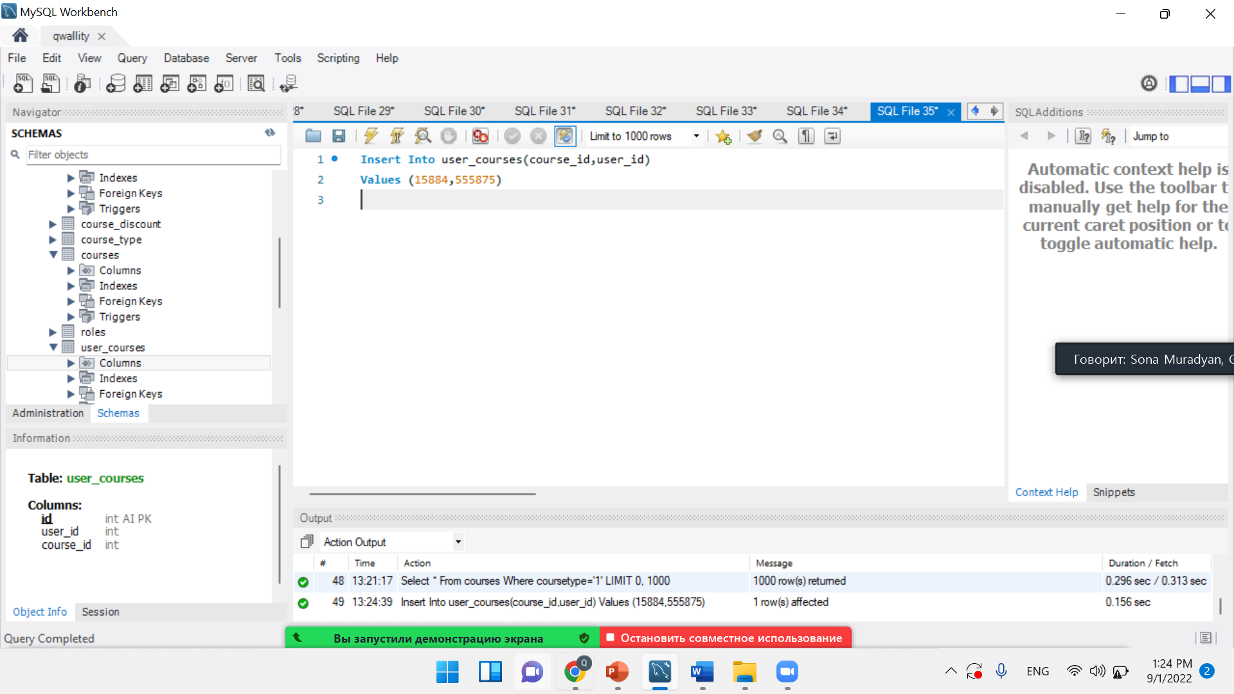

***Which will update one of the Advanced course price to ‘20’***

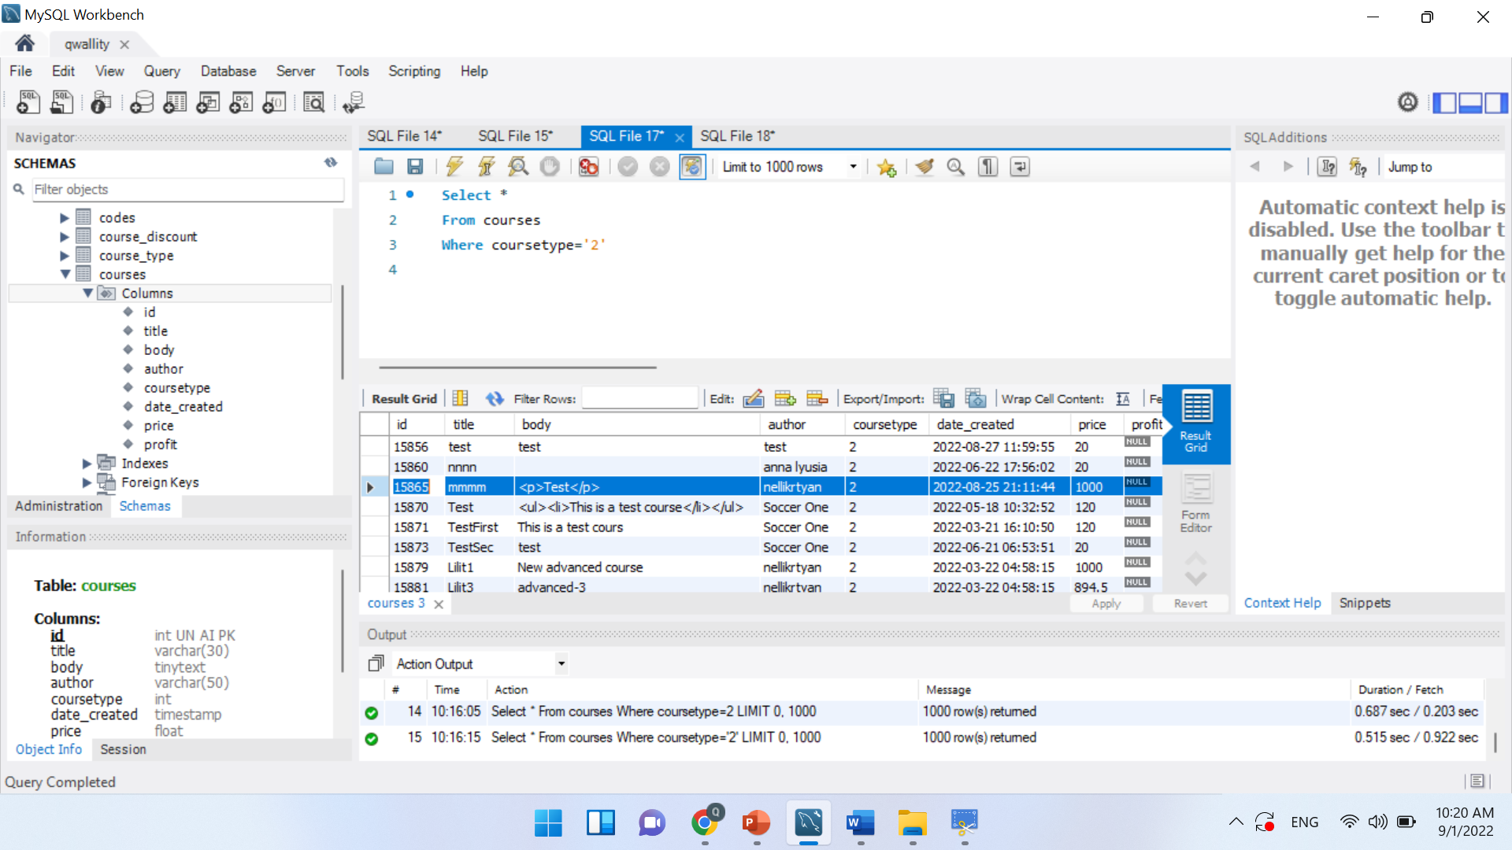

Syntax

Update courses

Set price=’20’

Where courses.id=15865

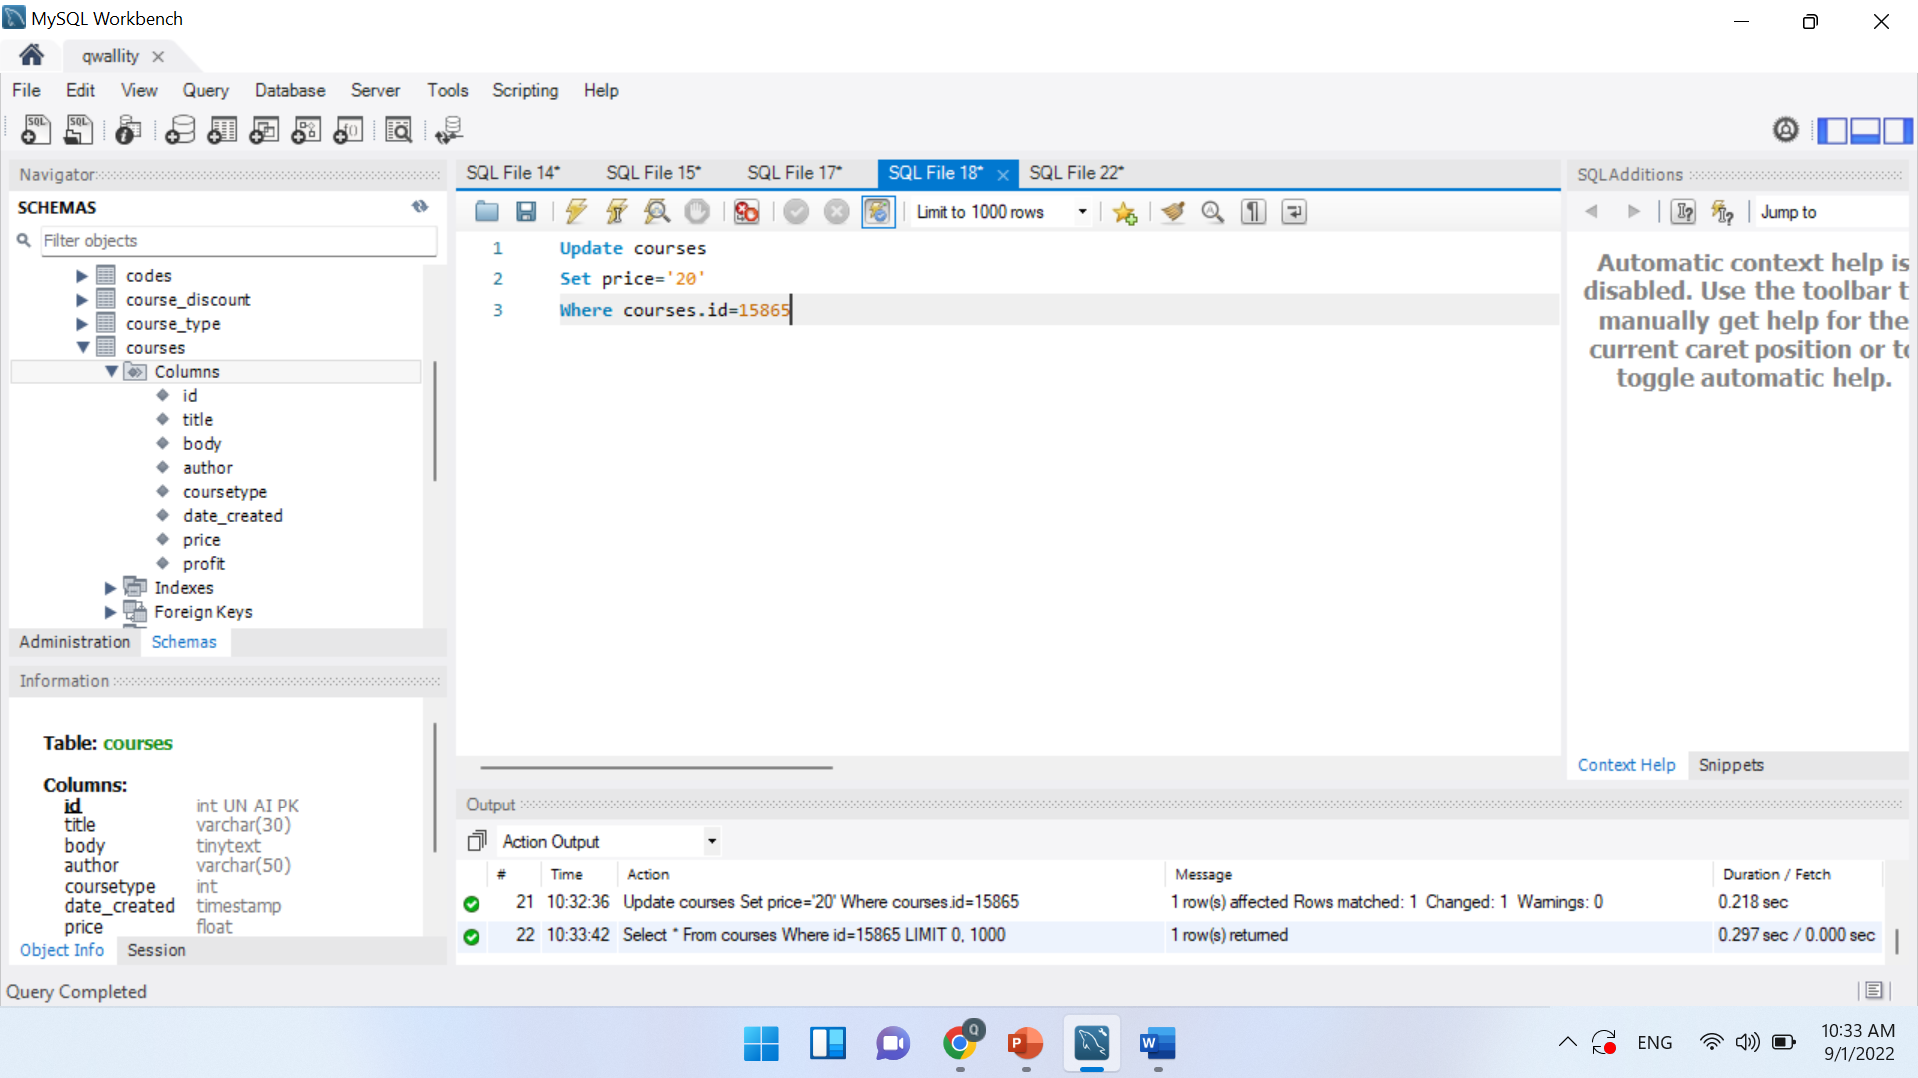

***Cheking in db***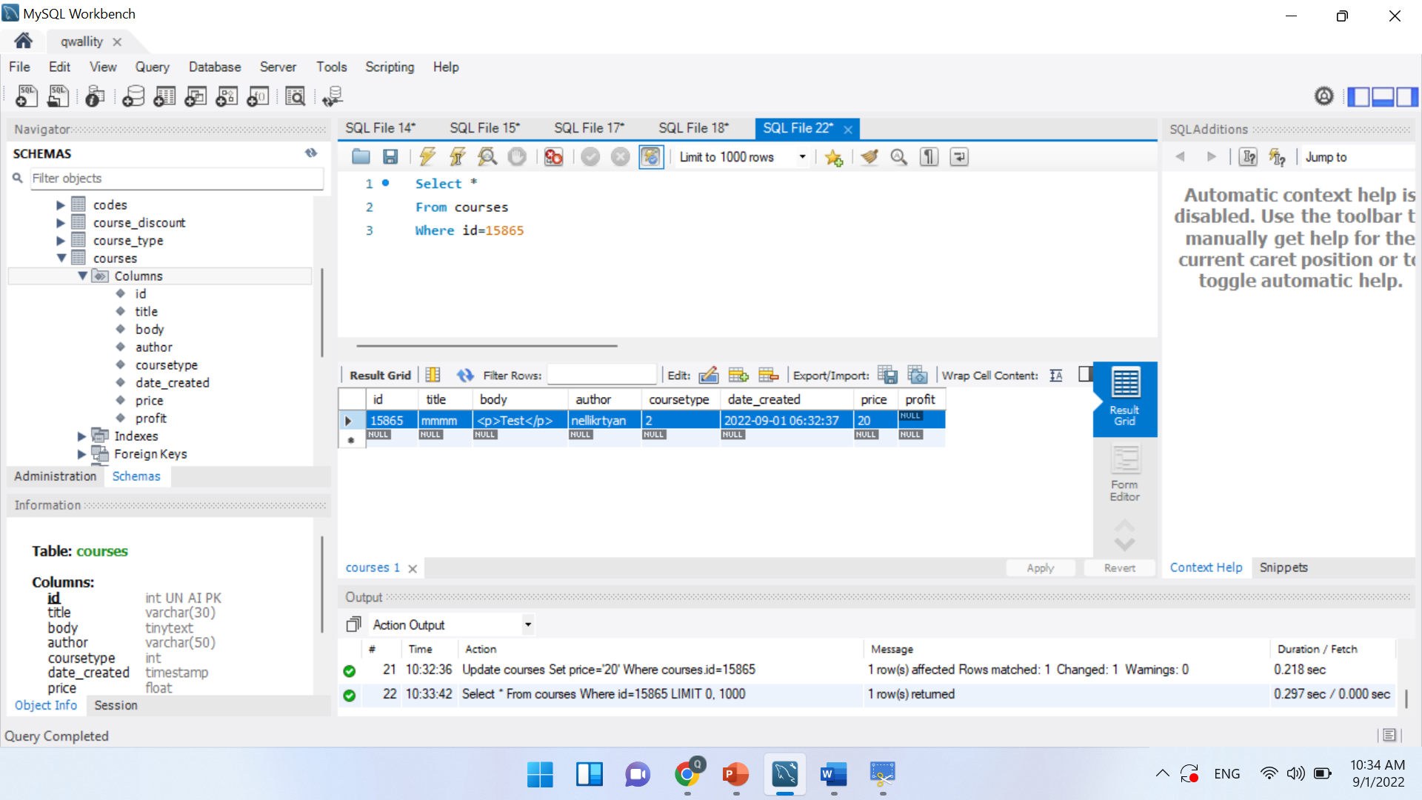

**Scenario 3: Working with users**

**Queries**

***Which will give count of the all non admin and admin users***

***Syntax***

Select Count(id),role_id

From users

Where role_id IN (1,2)

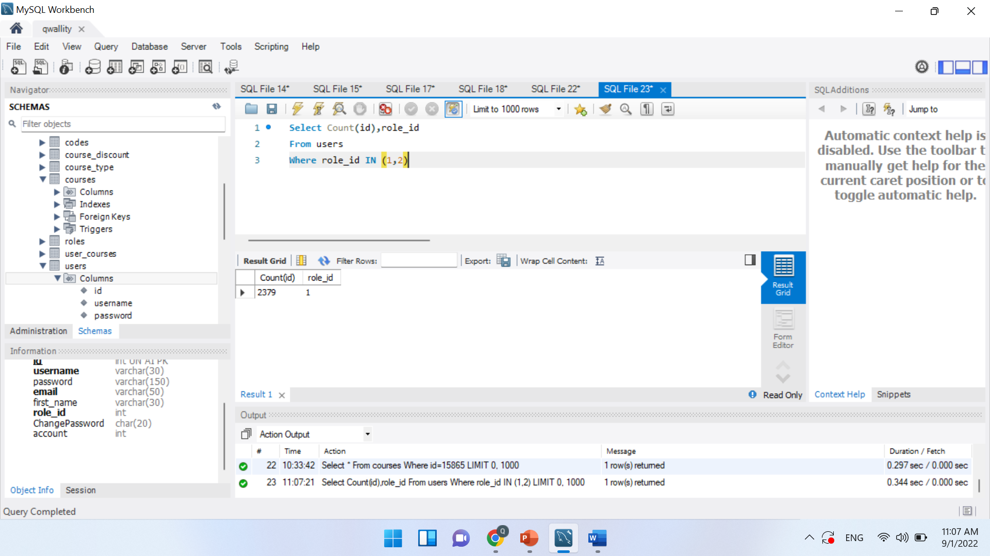

***Which will select all users who account is more than 100***

***Syntax***

***Select Count(id)***

***From users***

***Where account>100***

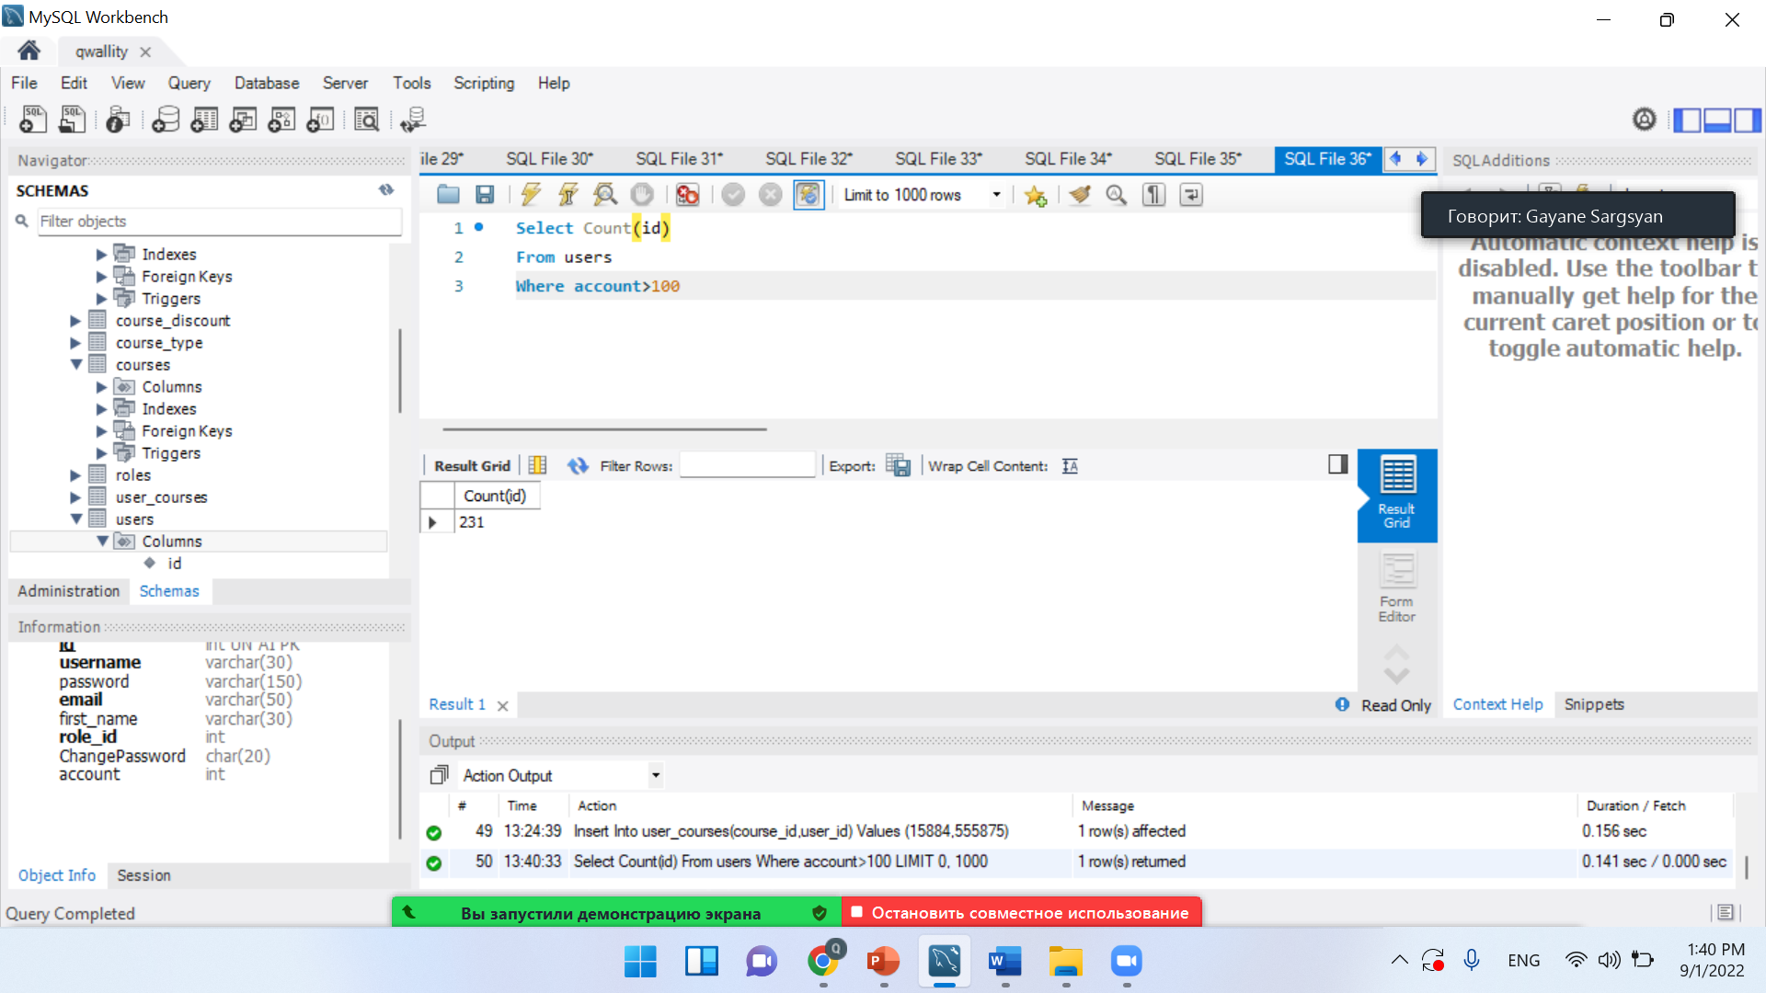

***Which will group by username***

***Syntax***

Select *

From users

Group by username

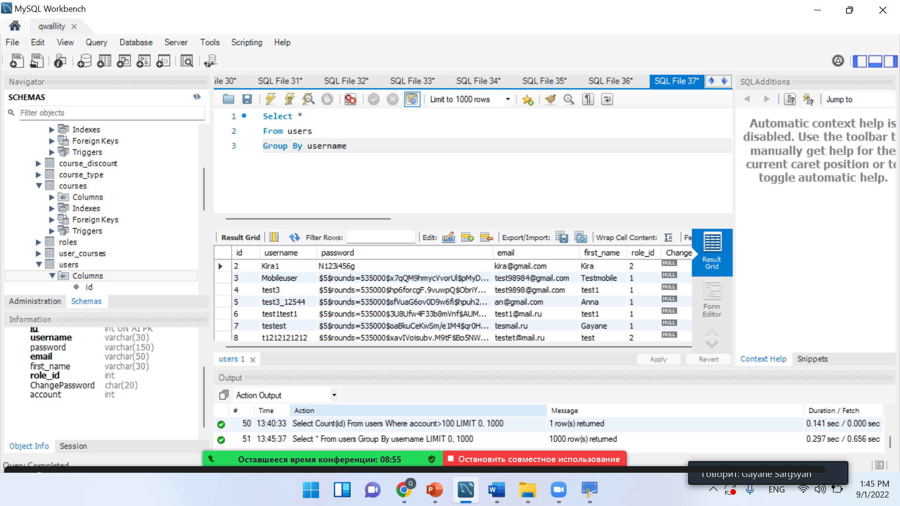

***Which will give all users who name start with ‘Ann’***

***Syntax***

Select *

From users

Where username Like 'Ann%'

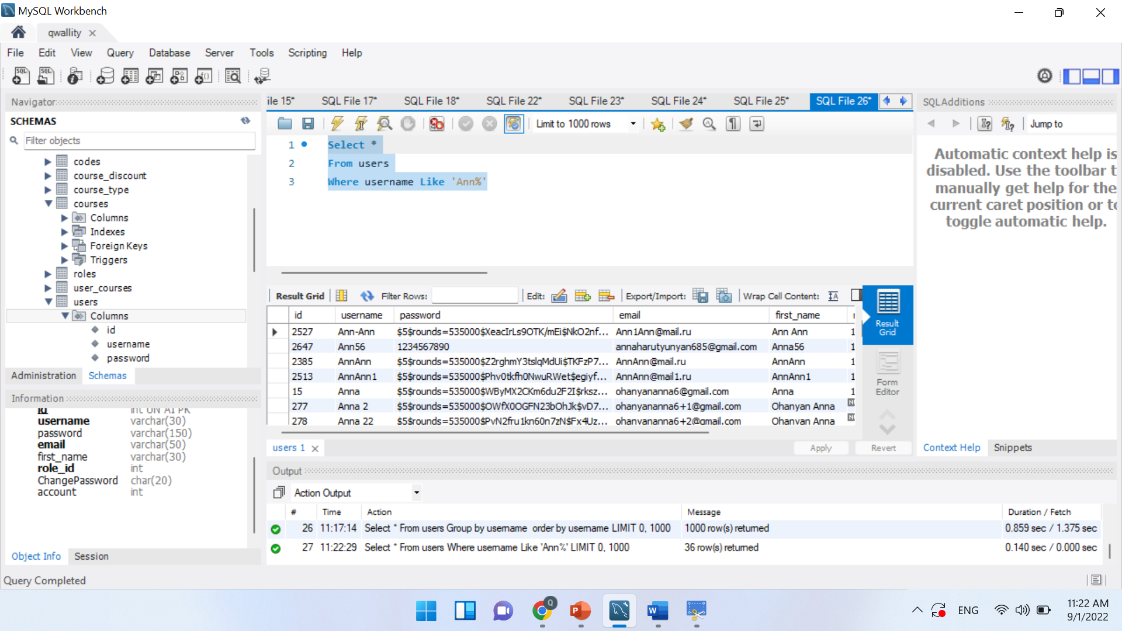

***Which will give all users who name 2nd letter is ‘n’***

***Syntax***

Select *

From users

Where username Like '_n%'

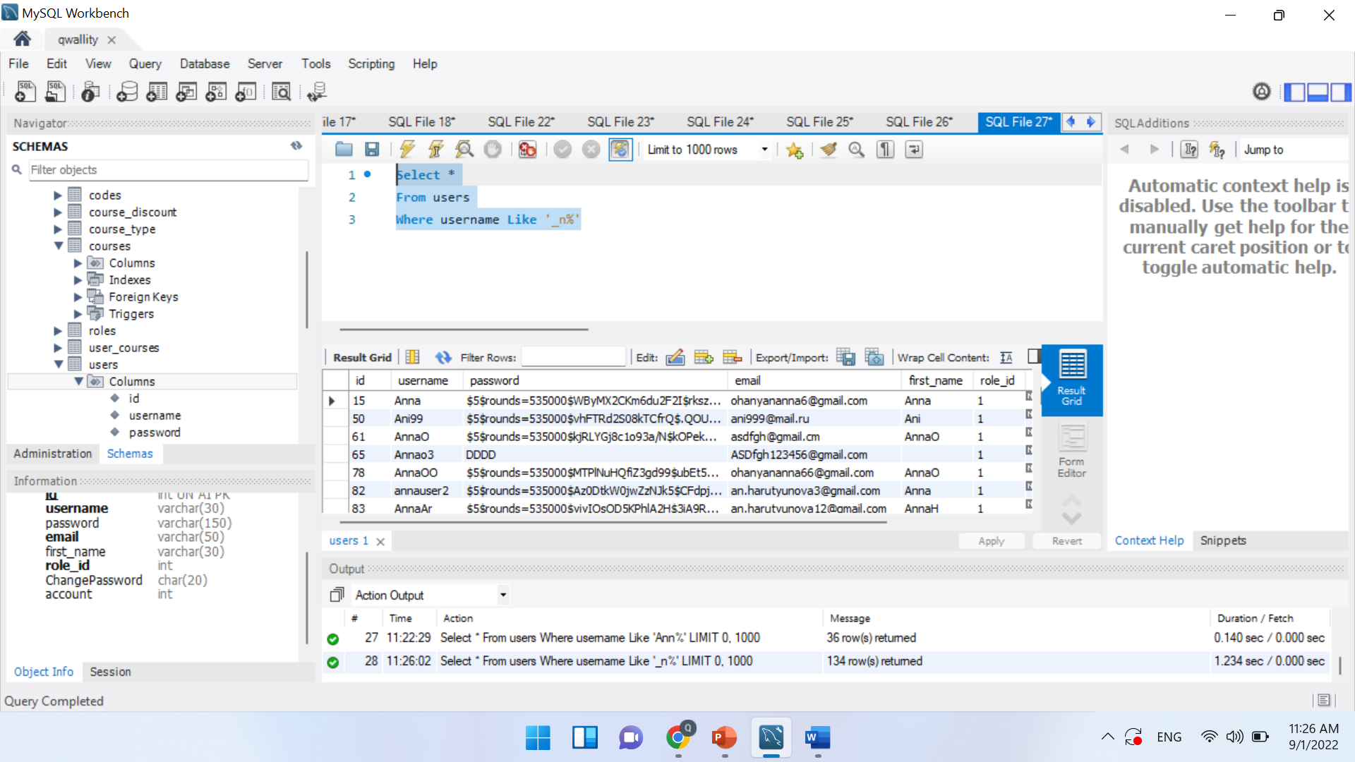

***Which will insert new user with all fields (encoded password should be copied from db)***

***Insert Into***

***Values***

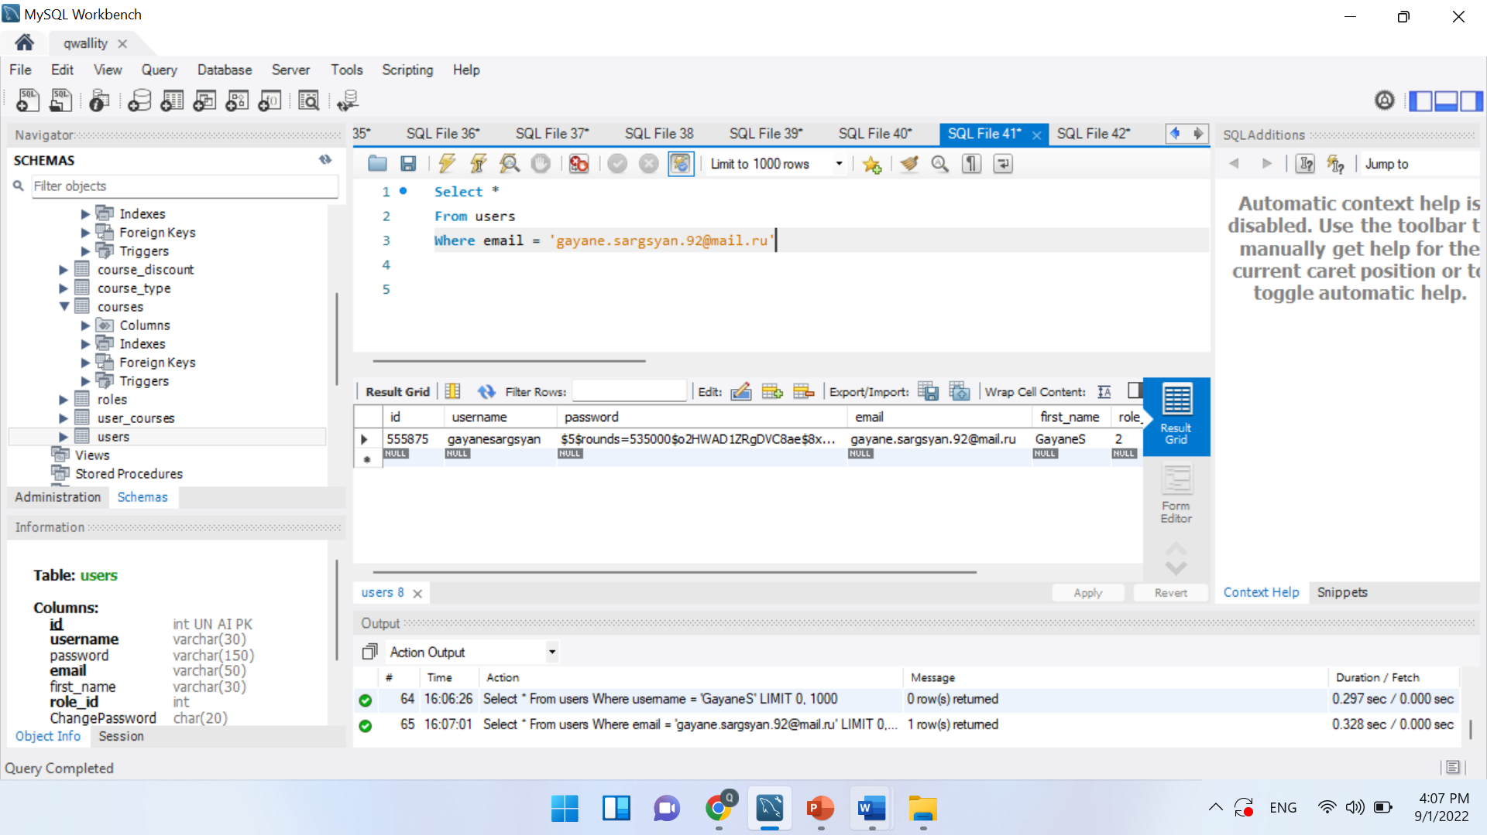

Encoded password - $5$rounds=535000$o2HWAD1ZRgDVC8ae$8xq.NWDW4f8C8aMt/vz7CRs1GlL9oXqvPY9r2u9A7FD

Syntax

Insert Into users(username, password,email,first_name,role_id,ChangePassword, account)

Values

(‘User33’,’$5$rounds=535000$o2HWAD1ZRgDVC8ae$8xq.NWDW4f8C8aMt/vz7CRs1GlL9oXqvPY9r2u9A7FD’,’gr3@gmail.com’,’group3333’,2,’Null’,1000)

**Scenario 4: Working with usergroup -roles**

**Queries**

**Write the query which will add new non admin user(encoded password should be copied from db)**



Encoded password - $5$rounds=535000$o2HWAD1ZRgDVC8ae$8xq.NWDW4f8C8aMt/vz7CRs1GlL9oXqvPY9r2u9A7FD

SYNTAX

Insert Into users(username, password,email,role_id)

Values ('gasoka','$5$rounds=535000$o2HWAD1ZRgDVC8ae$8xq.NWDW4f8C8aMt/vz7CRs1GlL9oXqvPY9r2u9A7FD ','g3@gmail.com',2)

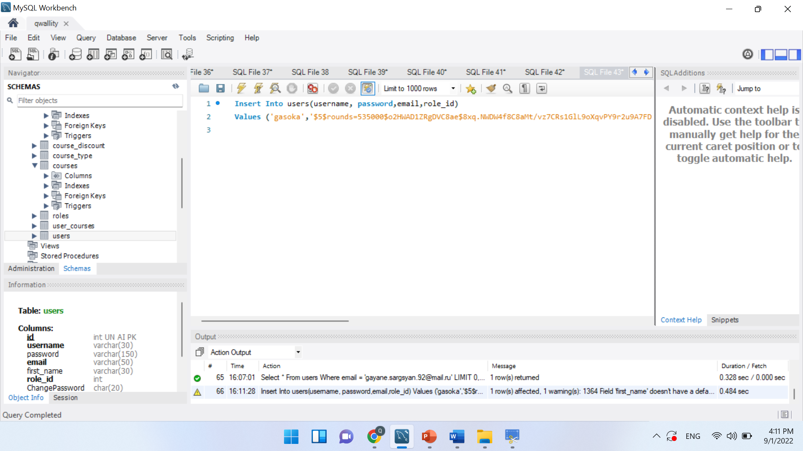

Select*

From users

Where email='g3@gmail.com'

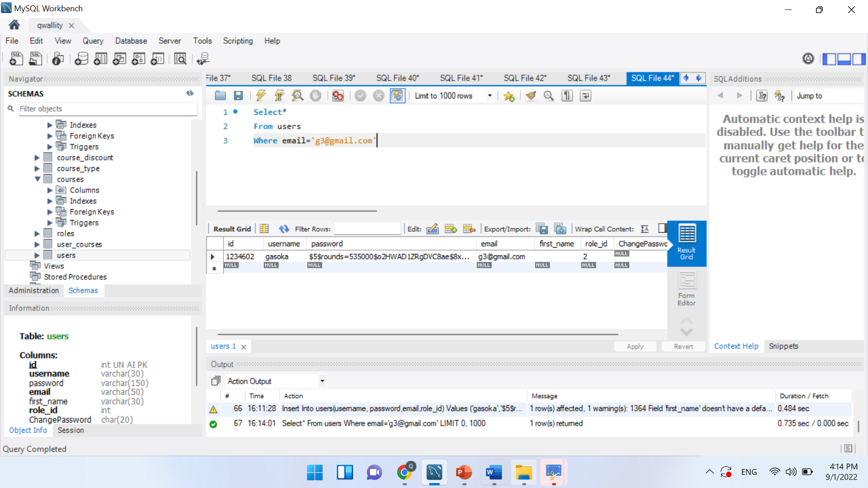

**Check that non admin can login to the system via application**

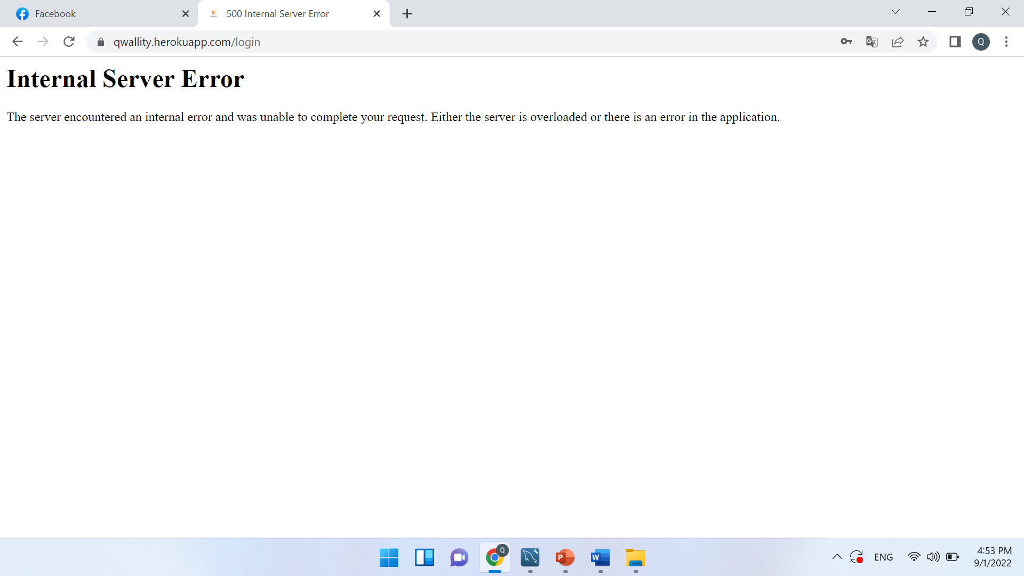

**Update role as admin in DB**

Syntax

Update users

Set role_id=1

Where email='g3@gmail.com'

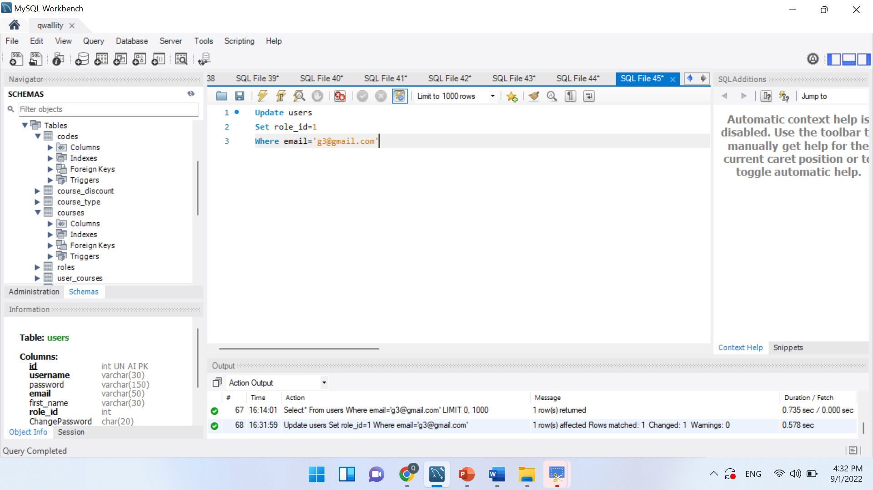

Select *

From users

Where email='g3@gmail.com'

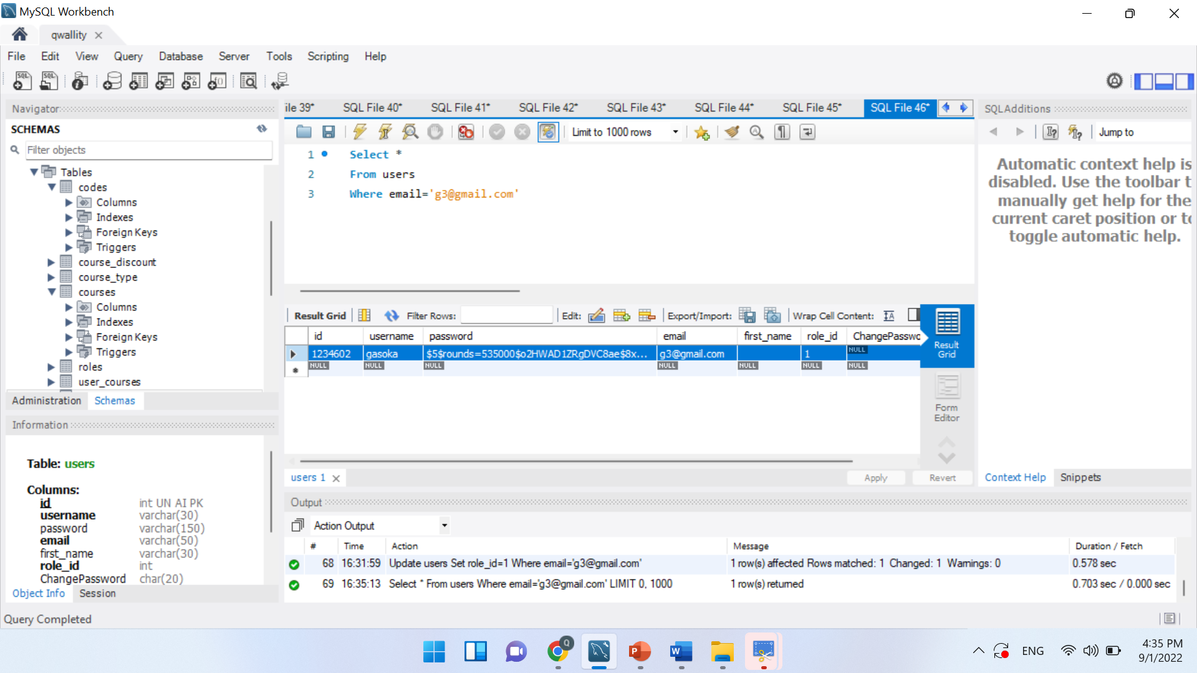

**Login into system and check that you are admin**

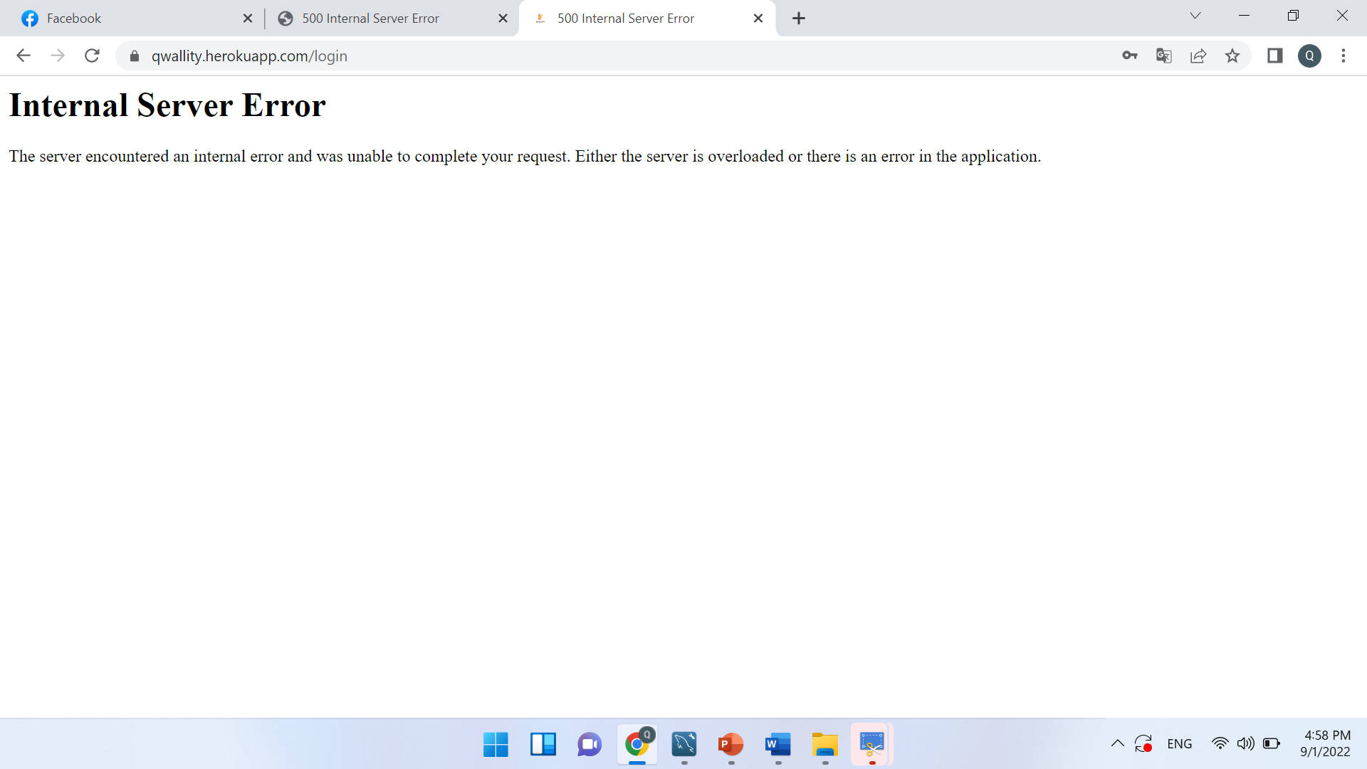

**Change user pass in DB**

Syntax

Update users

Set password='changepassword'

Where email='g3@gmail.com'

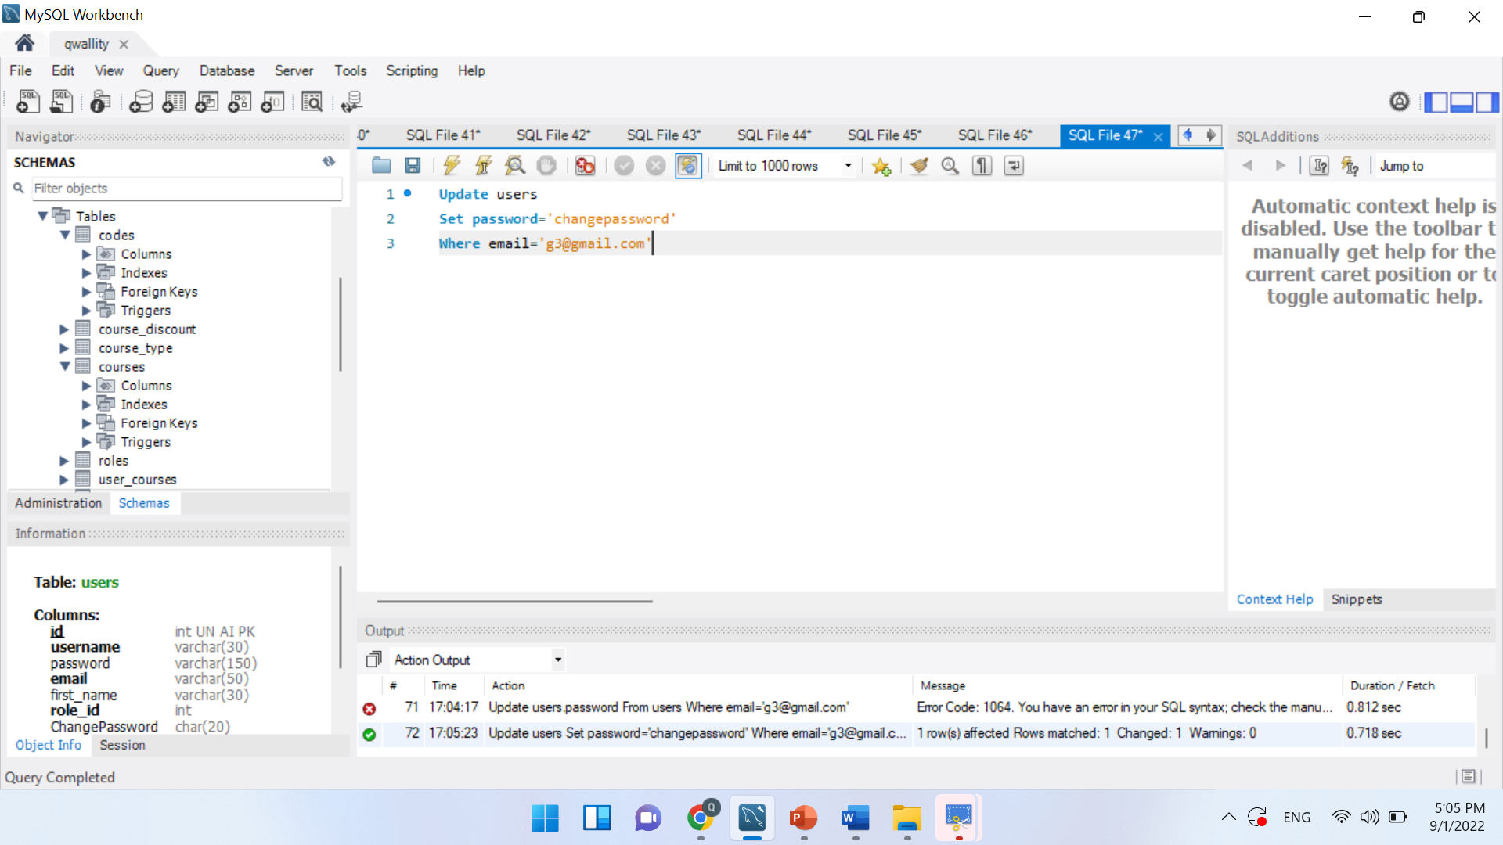

Select *

From users

Where email='g3@gmail.com'

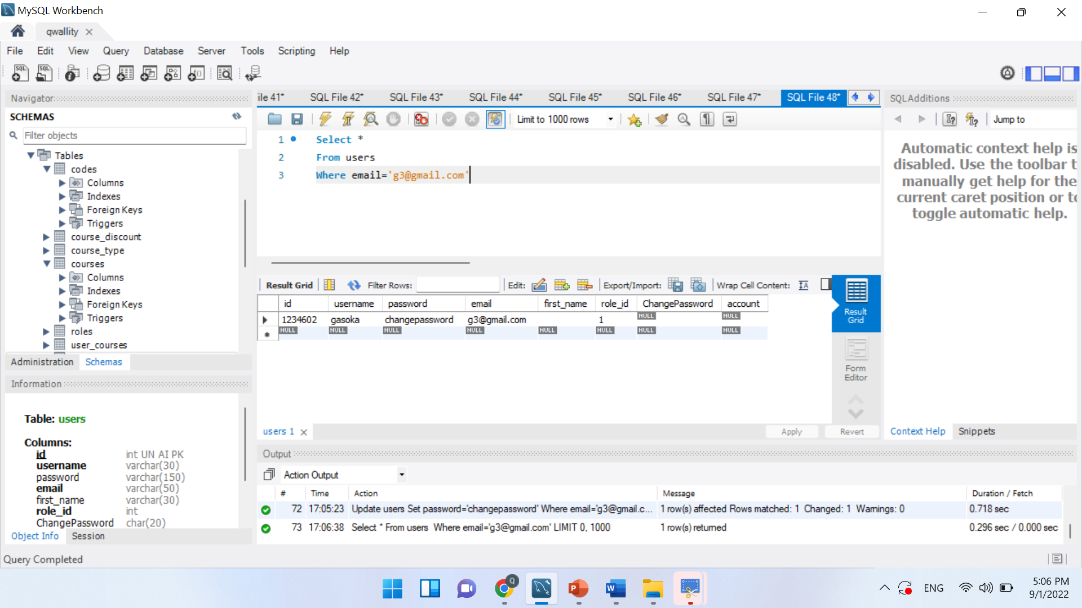

**Try to login again in system**

